PERSONALIZED E-LEARNING COURSE RECOMMENDATION SYSTEM
Methodology, Novelty and Key Contributions
Department of Computer Science and Engineering, [COLLEGE NAME]
Batch C7 (CSE-C) · Academic year [ACADEMIC YEAR]
Table 1: Project team
S.No. | Student name | Roll number
1 | PITTALA AKHILA | 23K91A05J3
2 | MUNDALA SANDHYA | 23K91A05G5
3 | MULA THANUJ REDDY | 23K91A05G4
4 | MAJJIGAPU JAGADESHWAR REDDY | 23K91A05E1

Project guide: K GAYATHRI
Chapter and section numbers quoted in the text (for example Section 6.6 or Chapter 8) refer to the full project report, 17.Final Document. Figures and tables in this document are numbered from 1.

1. OVERVIEW OF THE METHODOLOGY
This document describes how the system works from end to end and what is new in it. Part 1 gives the pipeline, the data, the algorithms and the reasons they were chosen; Part 2 sets the work against the base paper and separates what is new from what is standard; Part 3 lists the contributions.

6.1 Overall methodology
The method has two phases that meet in one module. In the offline phase the script scripts/train_pipeline.py generates a synthetic, OULAD-like table of learner behaviour, splits it by learner, fits three classifiers that predict whether a learner-week ends in success, fits a pair of logistic regressions per learning action to estimate its benefit, runs an offline policy evaluation and a fairness audit, and saves everything the application needs as joblib and JSON files. In the online phase every request for recommendations runs rank_courses() in app/recommender.py, which combines a content-based score, simple rules, the learner's recent behaviour and the two model outputs into one ranked list with an explanation per course. The structure follows the base paper [1], which couples a success predictor, an uplift estimate of the benefit of each learning action and offline policy evaluation, but it replaces the paper's OULAD data with a synthetic generator and does not implement its reinforcement-learning agent (Section 6.5 and Chapter 10).
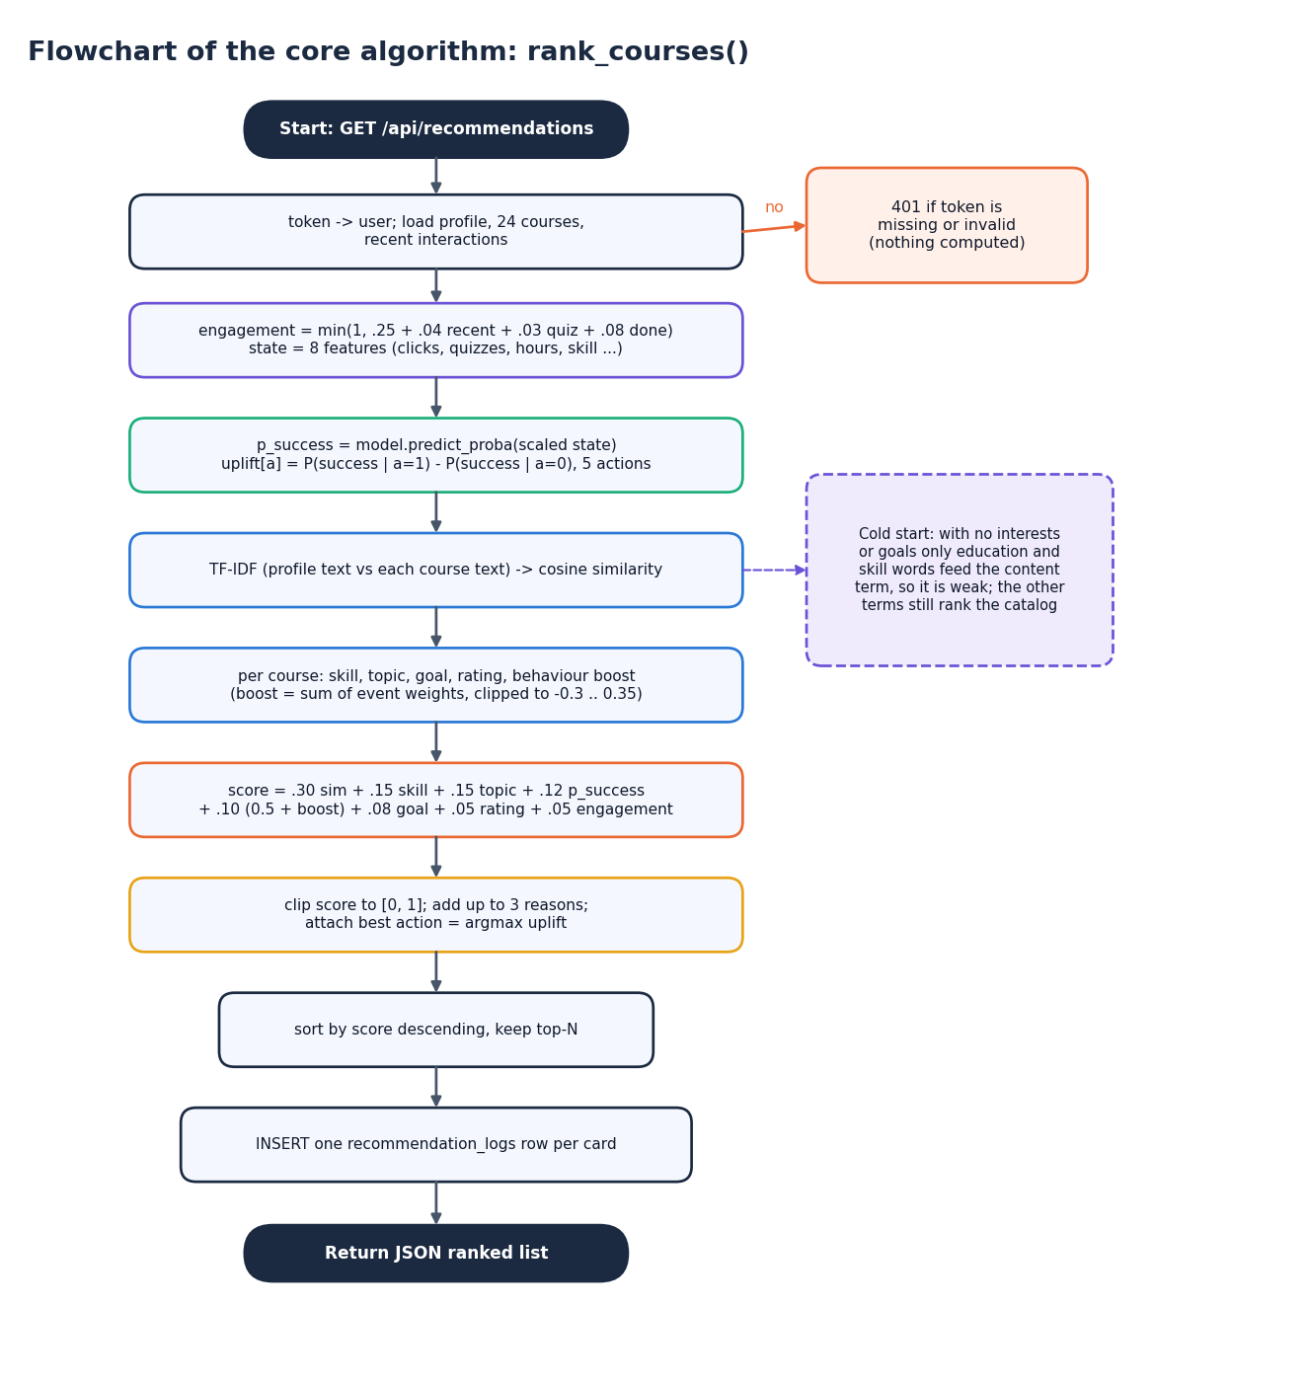
Figure 1: The online ranking procedure (flowchart repeated from Chapter 5)

6.2 Data
The training data are synthetic. acquire_data() first sends one short request to the Open University Learning Analytics Dataset page [4] but never reads a file from it; whatever the response, it then generates a table with the same kind of columns, tagged synthetic-oulad-like-fallback-v1. The real OULAD was not downloaded and no number in this report comes from it. The generator is seeded (seed 42), so a re-run reproduces the shipped files exactly.
The table has 2,200 learners observed for 12 weeks, that is 26,400 learner-week rows. For each learner the generator draws an age band (0-35, 35-55 or 55 and over, with probabilities 0.6, 0.3 and 0.1), a gender, an education level, a skill code (0, 1 or 2) and a latent ability that rises with skill and postgraduate education and falls slightly for the oldest band. Each week it draws the number of clicks from ability plus noise, whether the learner took a quiz or posted in the forum, homepage visits, content clicks and an assessment score (60 + 10 x ability + noise, clipped to 0-100); a completion flag is set in week 12 for learners with ability above 0.5.
The label is generated, not observed: a learner-week is a success when the hidden assessment score is at least 50 and a uniform random draw falls below 0.55 + 0.2 x (score - 50) / 50. The label is therefore noisy by construction, and the assessment score is not one of the eight features the deployed model sees. The learning action of a week is the first of quiz, content, forum, homepage or continue-course that applies to that week's behaviour (a quiz if one was taken, otherwise content if content clicks exceed four, and so on), so actions are assigned by a rule on behaviour and not at random.
Table 2: The synthetic data set
Item | Value
Source tag | synthetic-oulad-like-fallback-v1 (real OULAD not used)
Learners x weeks | 2,200 x 12 = 26,400 rows
Success rate | 44.0 %
Logged actions | quiz 8,424, content 5,292, continue_course 5,185, homepage 5,172, forum 2,327
Features given to the models | cum_clicks, recent_clicks, quiz_count, forum_count, completions, engagement, weekly_hours, skill_code
Hidden columns | assessment score (drives the label), age band, gender, education, homepage hits, content clicks

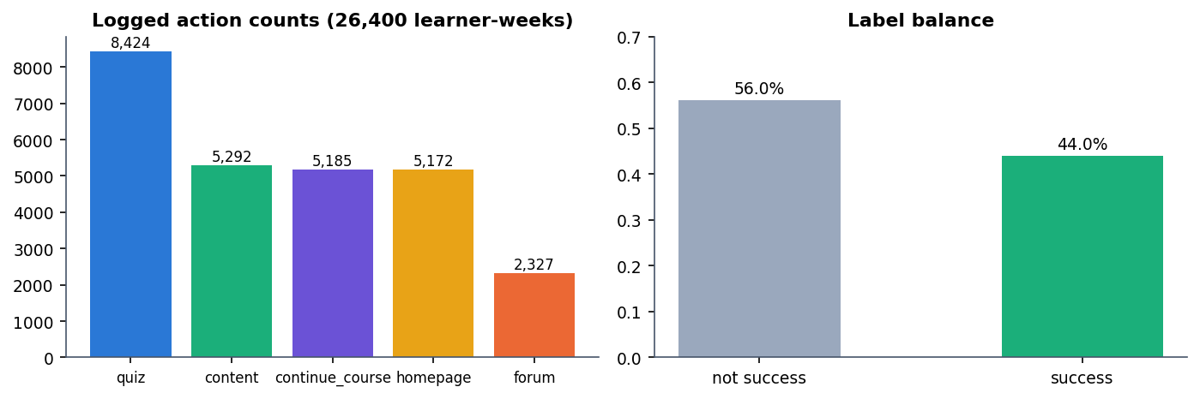
Figure 2: Logged action counts and label balance of the synthetic data
Correlation of each feature with the label is weak (largest: recent_clicks 0.183 and engagement 0.182, forum_count 0.002), which sets the ceiling for any model trained on these features; Chapter 8 shows that adding the hidden assessment score lifts the test AUC from 0.60 to 0.80, so the weak signal is a property of the generated data and not of the models.
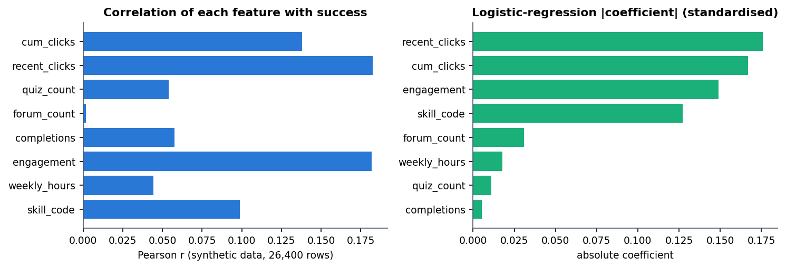
Figure 3: Correlation of each feature with success (left) and the logistic-regression coefficients (right)

6.3 Learner-level split and success models
The rows are split by learner, not by row, so no learner appears on both sides: the learner ids are shuffled with seed 42 and cut 80 / 10 / 10, giving 21,120 training rows (1,760 learners), 2,640 validation rows (220 learners) and 2,640 test rows (220 learners). A StandardScaler is fitted on the training rows only. Three classifiers from scikit-learn [13] and XGBoost [12] are trained:
• Logistic regression (max_iter=1000), the interpretable baseline;
• Random forest [15] with 200 trees;
• XGBoost with 300 trees, maximum depth 5, learning rate 0.05, subsample and column sampling 0.9.
The model with the highest validation AUC is selected and saved; the test split is used only for the reported metrics, at a decision threshold of 0.5. On the shipped run logistic regression wins (validation AUC 0.6035), and Chapter 8 shows that it is selected in four of six data-generation seeds (seed 42 included). The saved file is called xgb_model.joblib for historical reasons; it holds whichever model was selected, which is logistic regression in the shipped build.
Table 3: Success models on the held-out test split (seed 42)
Model | Val. AUC | Test AUC | Accuracy | F1 | Brier
Logistic Regression (selected) | 0.6035 | 0.6028 | 0.5936 | 0.4146 | 0.2378
Random Forest | 0.5550 | 0.5439 | 0.5311 | 0.4463 | 0.2837
XGBoost | 0.6008 | 0.5994 | 0.5955 | 0.4437 | 0.2400

One seed run (data generation, three models, uplift models) takes about 6.0 s on the development machine; the launcher prints "1 to 3 minutes" for the first run, which includes installing and the slower policy-evaluation loop.

6.4 Estimated benefit of a learning action (T-learner)
For each of the five actions (quiz, content, forum, homepage, continue-course) the script fits a T-learner [16]: one logistic regression on the learner-weeks where that action was taken (the treated arm) and one on all the other weeks (the control arm). For a learner state x the estimated benefit is the difference of the two predicted success probabilities. This is the one-versus-rest form of the uplift idea described in the base paper [8], [1]. An action is fitted only when both arms have more than 200 rows and both outcomes; otherwise its benefit is reported as 0.
benefit(a | x) = P(success | x, treated by a) - P(success | x, not treated by a) [two logistic regressions per action] (1)
At run time uplift_scores() evaluates the ten models on the learner's current state; the action with the largest benefit becomes the suggested action of every card, and its benefit is shown as the estimated benefit. Because the actions were assigned by a rule on behaviour in a synthetic log, these numbers are associations learned from that log, not proven causal effects, and the interface says so ("based on observed learning patterns, not proven causal effects"). Two further consequences are measured in Chapter 8: the benefits can change sign after a handful of events, and because the benefit depends only on the learner state the same suggested action appears on every card of one learner's list. If the bundle cannot be loaded, a state-based heuristic supplies the five numbers instead.

6.5 Offline policy evaluation and what is not implemented
Following the evaluation practice of the base paper, the script estimates the value of the policy "give each learner-week the action with the largest estimated benefit" from the logged test rows. A multinomial logistic regression on the learner state estimates the logging policy's propensity of the logged action; propensities are clipped to [0.02, 0.98], and the importance weight is 1 when the target action equals the logged one (otherwise 0), divided by the propensity and capped at 10. Three estimators are reported [5]:
IPS = mean(w r) SNIPS = IPS / mean(w) DR = mean( q(x) + w (r - q(x)) ) ESS = (sum w)^2 / sum(w^2) (2)
Here r is the observed success, q(x) the selected model's predicted success and ESS the effective sample size. The shipped run gives IPS 0.0088, SNIPS 0.6652 and DR 0.4355 with an effective sample size of 9.1 out of 2,640 rows. An effective sample size of about nine means a handful of rows carry all the weight, so these values are not evidence that the policy improves outcomes; they are reported as a transparency feature of the application, and the stored note calls them an observational offline estimate, not a live experiment.
Not implemented: the base paper's Actor-Critic reinforcement-learning agent, its causal regularisation, a collaborative-filtering model over many learners' course histories (the behavioural term of Section 6.8 is per learner) and any use of the real OULAD data. The project takes from the base paper only the success predictor, the uplift-style action estimate, offline policy evaluation and a fairness audit.

6.6 Fairness audit
The script groups the test rows by age band and by gender and reports, for each group, the number of rows, the observed success rate, the mean predicted success and the F1 score of the selected model. The audit is reporting only: no mitigation is applied, and the API note describes it as "transparent reporting, not a claim of perfect fairness". The result (Chapter 8) shows the lowest F1 for the 55-and-over band, which has only 204 test rows.

6.7 Content-based scoring
The text of a course is its title, description, topic, category, tags and skill level; the text of a learner is the interests, preferred topics, goals, course preferences, education and skill level from the profile. For every request a TfidfVectorizer (English stop words, at most 2,000 terms) is fitted on these 25 short documents (the profile plus the 24 courses) [14] and the content score of a course is the cosine similarity between its vector and the learner's.
content(c) = cos( tfidf(profile), tfidf(course c) ) (3)
Fitting on 25 documents each time keeps the code simple and needs no stored index, at the price that the term weights change slightly with the catalogue, and that the catalogue is small enough that a whole recommendations request takes about 33 ms (Chapter 7).

6.8 Hybrid ranking, behaviour and explanations
The final score of a course is a weighted sum of eight terms, clipped to [0, 1]. The weights are fixed constants in the code and were not fitted on data; Chapter 8 reports a drop-one-term ablation of them.
score(c) = 0.30 content + 0.15 skill + 0.15 topic + 0.12 success + 0.10 (0.5 + behaviour) + 0.08 goal + 0.05 rating + 0.05 engagement (4)
Table 4: The eight terms of the hybrid score
Term | Weight | Definition in the code
content | 0.30 | TF-IDF cosine similarity between profile text and course text
skill | 0.15 | Skill compatibility: level difference 0, 1 or 2 between learner (Beginner 0, Intermediate 1, Advanced 2; All levels counts as 1) and course gives 1.0, 0.6 or 0.3
topic | 0.15 | Share of the learner's interest, topic and goal words (longer than two letters) found in the course's topic, category, tags and title; 0.5 if the learner has none
success | 0.12 | Predicted success probability of the selected model for the learner state (same value for every course); 0.55 if the model is unavailable
behaviour | 0.10 | 0.5 plus the behavioural boost of this course, from the learner's events on it, clipped to [-0.3, 0.35]
goal | 0.08 | 0.7 if any comma-separated goal appears in the course title, description or tags, else 0.4
rating | 0.05 | (rating - 3.5) / 1.5, clipped to [0, 1]
engagement | 0.05 | Engagement score of the learner (same value for every course)

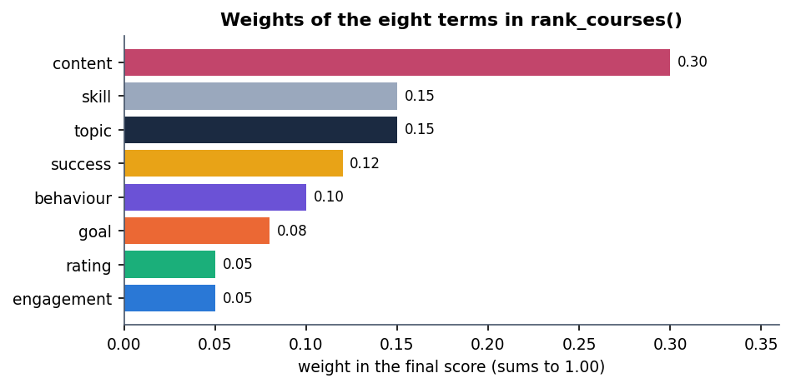
Figure 4: Weights of the eight terms in the hybrid score
Two of the eight terms (success and engagement, together 0.17 of the weight) are identical for every course of one learner, so they shift all scores together and cannot change the order; the order is decided by the other six terms. This is stated here because the "success estimate" shown beside each card is a property of the learner, not of the course.

Behavioural boost and engagement
Table 5: Event weights of the behavioural boost
Event | view | open | start | content | quiz | forum | save | complete | dismiss
Weight | 0.05 | 0.06 | 0.12 | 0.10 | 0.14 | 0.10 | 0.08 | 0.20 | -0.25

The boost of a course is the sum of the weights of the learner's events on that course, each multiplied by the event value (1.0 by default), clipped to [-0.3, 0.35]; an event type not in the table counts 0.03. The engagement score is computed from the last 200 events:
engagement = min(1, 0.25 + 0.04 x (view, open, start, content, quiz and forum events) + 0.03 x quizzes + 0.08 x completions) (5)
With no events the score is 0.25 (label "Getting started"); below 0.4 the label is "Getting started", below 0.7 "Steady learner" and otherwise "Highly engaged"; a learner who dismissed a course among the last five events and has a score under 0.45 is labelled "Needs a nudge".

Learner state for the models
The success and uplift models expect the eight training features, which learner_state_vector() builds from the profile and the logged events: cum_clicks is the number of events, recent_clicks that number capped at 20, quiz_count, forum_count and completions are the counts of those events, engagement is the score above, weekly_hours comes from the profile and skill_code is 0, 1 or 2. These definitions differ from the synthetic training weeks (where cum_clicks accumulates clicks), so the models are applied to a proxy of the state they were trained on; this is a limitation of the application, not something the offline metrics measure.

Explanations and the learning path
Each card carries up to three reasons chosen by rules: a content or topic reason ("Matches your interests (tag, tag)", "Aligned with your topic preferences in ..." or "Broadens your ... knowledge"), a skill reason ("Fits your current skill level", "Stretches you slightly beyond your level" or "A comfortable refresher"), "You have engaged with similar material before" when the boost exceeds 0.05, and "High estimated completion likelihood" when the predicted success exceeds 0.6. The learning path takes the top 12 courses, orders them by skill level (Beginner and All levels first, then Intermediate, then Advanced) and then by score, and keeps six; it uses no prerequisite graph.

2. NOVELTY AGAINST THE BASE PAPER
The base paper [1] is a research study: it estimates the effect of learning actions on real OULAD data [4] with uplift models, embeds those estimates in an Actor-Critic reinforcement-learning agent through causal regularisation, evaluates the learned policy off-policy and audits it by subgroup. This project does not reproduce that study and its numbers are not comparable with the base paper's. Its contribution is of a different kind: a working, explainable course-recommendation application that borrows part of the base paper's evaluation toolkit and reports its own results candidly. The table separates what is new in this work from what is standard practice that it reuses.
Table 6: Novelty against the base paper and standard practice
Aspect | Base paper | This project | New here?
Task | Prescribe learning actions and paths in MOOCs | Rank a 24-course catalogue for one learner, explain each card, and suggest a next action | Different task; the combination is the project's own design
Data | Real OULAD (32,593 enrolments) | Synthetic OULAD-like generator (26,400 learner-weeks); real OULAD never used | No: a limitation, stated everywhere
Recommendation layer | Policy over learning actions, not an explainable catalogue ranking | Eight-term hybrid score (content, skill, topic, success, behaviour, goal, rating, engagement) with plain-language reasons | Yes, as an engineered, inspectable design (weights hand-set)
Feedback loop | Offline trajectories | Nine event types logged through the API; ranking, engagement and success estimate recomputed on every request | Yes as an implementation; measured in a recorded example
Success model | XGBoost, AUC 0.795 on real data | LR / RF / XGBoost, validation-AUC selection; deployed Logistic Regression, test AUC 0.603 | No: standard models
Action benefit | Uplift modelling of treatment effects | One-vs-rest T-learner, two logistic regressions per action [16] | No: standard method; shown as an estimate, not a causal effect
Policy learning | Actor-Critic agent with causal regularisation | None: the highest estimated benefit is shown as a suggestion | Not reproduced
Policy evaluation | IPS, SNIPS and doubly robust values with intervals | IPS, SNIPS, DR with the effective sample size (9.1) reported beside them | Partly: same estimators; candid weak-evidence reporting is the addition
Fairness | Subgroup analysis by age and gender | Audit by age band and gender, shown in the application | Partly: same idea, exposed to the user
Honest evaluation | Benchmarks on OULAD | Six-seed repeat, a ceiling check, a drop-one-term ablation, a persona check, a latency study; the hybrid is shown not to beat content-only on the persona check (0.733 vs 0.800 P@3) | Yes for this project: the analysis exposes the system's weaknesses

What is not new. TF-IDF cosine similarity [14], hybrid combination of signals, logistic regression, random forests, gradient boosting, meta-learner uplift estimation and importance-weighted policy evaluation are all established techniques, and the OULAD-style schema is public. The value of the project lies in joining them into one reproducible, tested and inspectable application and in measuring it honestly. In particular, no claim is made that the hybrid ranker, the T-learner or the policy values are better than any alternative.

3. KEY CONTRIBUTIONS
The contributions of the project, in order of importance:
1. An end-to-end, explainable course-recommendation application. FastAPI, SQLAlchemy and SQLite behind eighteen JSON routes, a React front end with twelve screens and the original server-rendered interface, with every recommendation card carrying a match percentage and up to three reasons.
2. A transparent hybrid ranking engine. Eight interpretable terms with documented weights, a drop-one-term ablation, and a persona check in which both personalised rankers reach P@3 of 0.733 (hybrid) and 0.800 (content-only) against 0.200 for popularity.
3. A measurable feedback loop. In a recorded example six events raise the score of the studied course from 0.4867 to 0.5514 and move a dismissed course from rank 3 to 4, without retraining.
4. A reproducible success-and-action pipeline with honest diagnostics. Three success models compared over six seeds (logistic regression 0.614 +- 0.012 AUC), a ceiling check that explains the weak signal, a one-vs-rest T-learner, IPS/SNIPS/DR evaluation reported with its effective sample size (9.1) and a fairness audit.
5. A verified engineering base. 5 automated tests, a 33-check smoke test, a responsive-layout check at three widths in light and dark themes, and measured latency (32.8 ms mean for eight ranked courses).
6. A candid account of what is missing: real data, collaborative filtering across learners, a reinforcement-learning agent, a prerequisite graph, real feedback and a live experiment.

